IMPORTANT NOTICE & NEWSLETTER
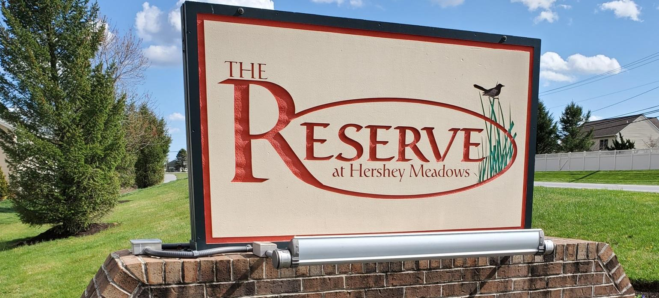
www.thereservecondos.com.
April 2021
Greeting to our homeowners and residents!
This update from your Executive Board has information pertaining to some important changes:
HOA Monthly Fees: The Executive Board contracted with an engineering firm to have a Reserve Fund Study done. The last study was done some years ago and it was time for a professional engineer to review / update our anticipated capital expenditure costs. The Reserve Fund Study is available on the Reserve Condos webpage for your review. The study concluded that our Capital Fund Reserves are not sufficient to cover anticipated capital expenditures. The engineering firm provided the Executive Board with options to make up this difference. The Board has studied the report and the recommendations and have determined that in order to have adequate funds available for capital expenditures in the future that we need to increase the monthly HOA fees.
Effective July 1, 2021 our HOA Monthly Fee will increase to $195 a month.
Monthly HOA Payment – Late Fees: The Executive Board has also voted to increase the late fee for those who cannot make their HOA payment on time. A lot of administrative work goes into collecting late fees from delinquent accounts. This late fee is now increased to $50 effective July 1st.
Dumpster Etiquette / Fines: We constantly have issues with people leaving furniture, beds and construction debris in or around the dumpster enclosures. ALL HOUSEHOLD TRASH BELONGS IN THE DUMPSTERS OR RECYCLING BINS. The association must pay to have these oversized items removed. Effective immediately anyone found not conforming with this policy will be fined $50.
If you have a large item to be hauled away, please contact a junk hauling company. Anything that does not fit in the dumpsters is to be hauled away at the resident’s expense. As homeowners and residents of The Reserve, we should all take pride in keeping our community beautiful and your Board is always looking into ways to improve the safety and appearance of our community. If you have an idea or concern please contact our property manager, Penn Equity at Annette@PennEquity.com.

No Grills 2nd Floor Balconies – Due to insurance regulations no grills of any type are not permitted to be used on the 2nd floor balconies. We recently had multiple mulch fires due to someone’s carelessness.
Speed Bumps – With the arrival of warm weather, the removable speed bumps will again be placed on our streets to limit speeding through the community. PLEASE SLOW DOWN! We have a number of children in the community and don’t want to see anyone injured.
Pets – Please pick up after your dogs. Also, please be aware that dogs are to be on leashes in the neighborhood. This is not only a bylaw of the association but also a South Hanover township ordinance. This is for your dog’s safety as well as the safety of the residents.
Vehicles / Street Parking – When parking on the street, please be mindful not to block access to your neighbors’ driveways or access to the mailboxes. All vehicles parked in The Reserve must be inspected and operational.
Common Areas – Please do not place items such as grills, fire pits, children’s pools, etc. in the common areas. Common areas include driveways, walkways and lawns. No vehicle maintenance is permitted in the community.
Lease Rules --The Rules and Regulations of The Reserve at Hershey Meadows require a full year lease. Copies of the lease should be provided to the management company within thirty (30) days of leasing your unit. Airbnb or short-term rentals are in violation of the by-laws and are subject to fines.
Exterior of Unit -- Please remember that you need to have approval from the Homeowners Association Board before making any changes to the outside of your unit. You can contact the Board, through Penn Equity, at (717) 930-6081 or Annette@pennequity.com.
Smoke Detectors – The smoke detectors originally installed in the units have an approximate lifespan of ten (10) years. If you have not changed your detectors, you should. Homeowners are responsible for replacing the hard-wired detectors.
Outside Lighting – The HOA replaces garage and entry lights when needed. These lights all work via an electric eye and come on at dusk. Streetlights are the responsibility of PPL. If you notice a streetlight that is not functioning, please let us know so we can contact PPL. Getting the pole number is very helpful when we contact PPL.
Dryer Vents -- We clean dryer vents once a year and only from the outside. If the dryer is not drying, the vent will need to be cleaned from the inside out at the unit owners’ expense.
HOA Fee Auto Debit -- We offer Auto Debit (form available on the website) for those who do not wish to remember to send in monthly payments. It is taken the 1st Friday of every month and is a free service to Association members.
The Reserve Executive Board
Andy Sawran
Nicole Vance
Ann Mudgett
Jeanine Zubey
Monica Hockenbrock

The Reserve at Hershey Meadows
Penn Equity – Property Manager Annette@pennequity.com (717) 930-6081

